**ST. XAVIER’S COLLEGE**

**(Affiliated to Tribhuvan University)**

**Maitighar, Kathmandu**



**OPERATING SYSTEM REPORT #07**

**SUBMITTED BY:**

Pradeep Dahal

017BSCIT029

2nd year/ 4th sem

|  |  |
| --- | --- |
|  | Signature |
| Mr. Rabin Maharjan  (Lecturer) |  |
| Department of Computer Science | |

**SUBMITTED TO:**

# Threads

As with processes, threads appears to run concurrently; the Linux kernel schedules them asynchronously, interrupting each thread time to time to give others a chance to execute. Threads exists within a process. GNU/Linux implements the POSIX standard thread API (pthreads). All thread functions and data types are declared in the header file *<pthread.h>*. The pthread functions are not included in the standard C library; they are in libpthread, therefore -lpthread should add when linking program.

**5.1 Thread Creation**

Each thread have their own thread ID as process, thread ID referred by type *pthread_t*. The pthread_create function create new threads. It has following formate.

*int pthread_create (pthread_t *thread, pthread_attr_t *attr, void *(*start_routine) (void*), void *arg);*

The pthread_exit function terminates the thread.

t*hread_exit(void *return_val);*

The pthread_join function waits other process for termination – equivalent of wait.

*int pthread_join(pthread_t th, void **thread_return);*

**Ex 5.1: Thread Creation (threadc.c)**

#include<stdio.h>

#include<pthread.h>

#include<unistd.h>

void *fun(void *para)

{

printf("This is the thread\n");

}

int main()

{ pthread_t id;

pthread_create(&id,NULL,&fun,NULL);

printf("This is the main thread\n");

pthread_join(id,NULL);

return 0;

}

**OUTPUT:**

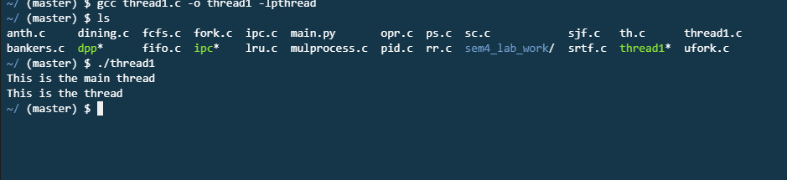

**Ex 5.2: Thread Creation (threadc.c)**

#include <stdio.h>

#include <unistd.h>

#include <pthread.h>

char ch;

int count;

struct param

{ char ch;

int count; };

void *printc(void *parameter)

{ struct param *p = (struct param*) parameter;

int i;

for(i=0;i<p->count;++i)

{ fputc(p→ch,stderr); }

}

int main()

{ pthread_t thread1_id;

pthread_t thread2_id;

struct param thread1_args;

struct param thread2_args;

thread1_args.ch = 'T';

thread2_args.count = 3000;

pthread_create(&thread1_id,NULL,&printc,&thread1_args);

thread2_args.ch ='t';

thread2_args.count = 2000;

pthread_create(&thread2_id,NULL,&printc,&thread2_args);

pthread_join(thread1_id,NULL);

pthread_join(thread2_id,NULL);

return 0;

}

Warning! :*Run this program as : gcc -o threadc threadc.c –lpthread*

**OUTPUT**



**STATEMENT : WRITE A PROGRAM USING THREADS THAT PRINTS SUM OF NUMBERS UP TO GIVEN POSITIVE NUMBER.**

#include <stdio.h>

#include <stdlib.h>

#include <pthread.h>

int sum = 0;

void* sum_runner(void* arg)

{ int *limit_ptr = (int*)arg;

int limit = *limit_ptr;

int i;

for(i = 0; i <= limit; i++)

sum += i;

}

int main(int argc, char **argv)

{ if (argc < 2)

{ printf("Usage: %s <num>\n", argv[0]);

exit(-1); }

int limit = atoi(argv[1]);

pthread_t tid;

pthread_attr_t attr;

pthread_attr_init(&attr);

pthread_create(&tid, &attr, sum_runner, &limit);

pthread_join(tid, NULL);

printf("Sum is %d\n", sum);

return 0;

}

**OUTPUT:**

